Teacher Notes for "How do muscles get the energy they need for athletic activity?"

In this analysis and discussion activity, students learn how muscle cells produce ATP by aerobic cellular respiration, anaerobic fermentation, and hydrolysis of creatine phosphate. Students use their understanding of these three processes to analyze their relative importance during athletic activities of different duration and intensity. Students learn how multiple body systems work together to supply the oxygen and glucose needed for aerobic cellular respiration. Finally, students use what they have learned to analyze how athletic performance is improved by the body changes that result from regular aerobic exercise.

As preparation for this activity, I recommend our analysis and discussion activity "How do organisms use energy?" (https://serendipstudio.org/exchange/bioactivities/energy). For additional background, you may want to have your students complete “Using Models to Understand Cellular Respiration” (https://serendipstudio.org/exchange/bioactivities/modelCR).

Learning Goals
In accord with the Next Generation Science Standards, this activity:
- helps students to learn the Disciplinary Core Ideas:
- LS1.C, "Cellular respiration is a chemical process whereby the bonds of food molecules and oxygen molecules are broken”, carbon dioxide and water are formed, and the energy released is used in the production of ATP from ADP and P. Then, the hydrolysis of ATP molecules provides the energy needed for many biological processes.
- LS2.B, "Photosynthesis and cellular respiration (including anaerobic processes) provide most of the energy for life processes."
- LS1.A, "Multicellular organisms have a hierarchical structural organization, in which any one system is made up of numerous parts and is itself a component of the next level."
- engages students in the Scientific Practices:
  - “Constructing Explanations: Apply scientific ideas, principles, and/or evidence to provide an explanation of phenomena…”
  - “Engaging in Argument from Evidence: Construct, use, and/or present an oral and written argument or counter-argument based on data and evidence.”
- illustrates the Crosscutting Concept, “Energy and matter: Flows, Cycles and Conservation: Within a natural or designed system, the transfer of energy drives the motion and/or cycling of matter.”
- helps students to prepare for Performance Expectations:
- HS-LS1-7, "Use a model to illustrate that cellular respiration is a chemical process whereby the bonds of food molecules and oxygen molecules are broken and the bonds in new compounds are formed resulting in a net transfer of energy."
- HS-LS1-2, "Develop and use a model to illustrate the hierarchical organization of interacting systems that provide specific functions within multicellular organisms."

Instructional Suggestions and Background Information
If your students are learning online, we recommend that they use the Google Doc version of the Student Handout available at https://serendipstudio.org/exchange/bioactivities/energyathlete. To answer questions 1 and 10, students can either print the relevant pages, draw on them and send pictures to you, or they will need to know how to modify a drawing online. To answer online, they can double-click on the relevant drawing in the Google Doc to open a drawing window. Then, they can use the editing tools to answer the questions. If you prepare a revised version of the Student Handout Word document, please check the format by viewing the PDF.

A key for this activity is available upon request to Ingrid Waldron (iwaldron@upenn.edu).
The following paragraphs provide additional instructional suggestions and background
information for your interest and possible use in class discussions.

To maximize student participation and learning, I suggest that you have your students work individually or in pairs to complete groups of related questions and then have a class discussion after each group of related questions. In each discussion, you can probe student thinking and help them to develop a sound understanding of the concepts and information covered before moving on to the next group of related questions.

If your students are not familiar with the term “coupled reactions”, you might want to have them read “Coupled chemical reactions” (https://www.britannica.com/science/cell-biology/Coupled-chemical-reactions).

Question 1 focuses on the hydrolysis of ATP to provide the energy for muscle contraction. The figure below provides more detail about the role of ATP in muscle contraction.
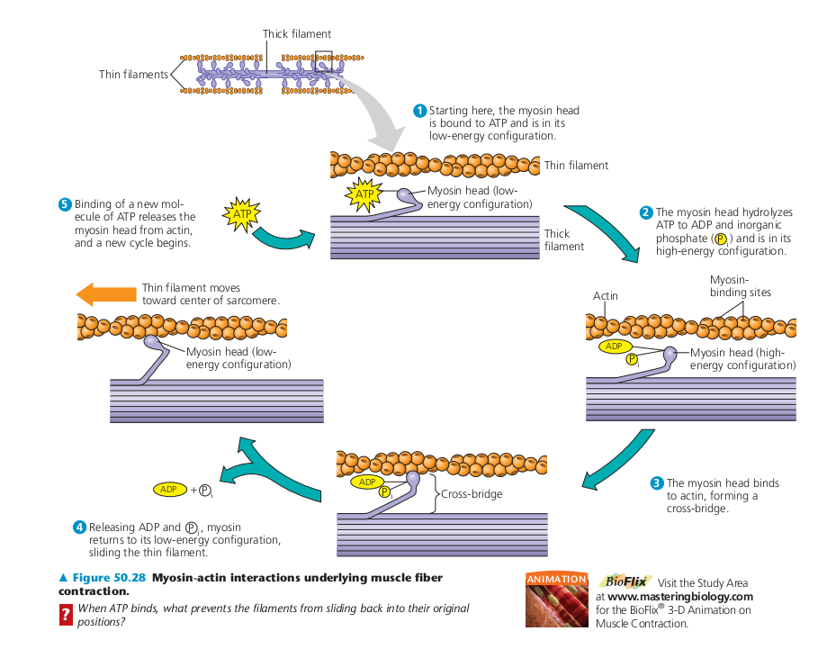
(http://classconnection.s3.amazonaws.com/938/flashcards/1810938/png/screen_shot_2012-10-22_at_14201_am1350884481342.png )

For question 3, it should be relatively easy for students to copy the information about how ATP is produced from the figure above in the Student Handout. Some students may find it more challenging to show how the hydrolysis of ATP provides input for muscle contraction since the arrows will point from right to left instead of from left to right. To facilitate class discussion of answers to question 3, you may want to have each small group of students prepare their consensus answer on a whiteboard, so they can more effectively present and compare their answers.

Although this activity focuses on muscles, students should be aware that most types of cells are constantly using aerobic cellular respiration of organic molecules like glucose to make ATP and using hydrolysis of ATP to provide the energy for biological processes (e.g. synthesizing molecules, pumping ions into and out of cells, and moving molecules within cells). On average, each ATP molecule in a human body is used and re-synthesized more than 30 times per minute when a person is at rest and more than 500 times per minute during strenuous exercise.

Both aerobic cellular respiration and anaerobic fermentation begin with glycolysis, when glucose is broken down to 2 pyruvate and 2 ATP are produced. (See the figure on the top half of page 2 of the Student Handout.) In the process of glycolysis, NAD+ is reduced to NADH. For
glycolysis to continue, NADH must be oxidized back to NAD+. When O₂ is available as an electron acceptor, NADH enters the electron transport chain and is oxidized to NAD+ in a process that contributes to the production of ATP (as part of aerobic cellular respiration). When O₂ is not available, the pyruvate produced by glycolysis reacts with NADH to produce lactate and NAD+ (as part of anaerobic fermentation). | 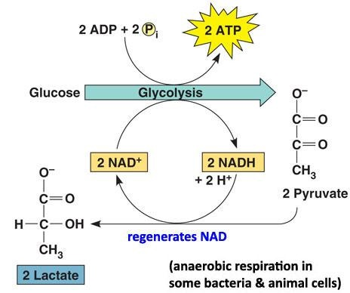  (http://test.classconnection.s3.amazonaws.com/529/flashcards/475529/jpg/lactic-acid-fermentation.jpg)

Lactate produced by anaerobic fermentation is mainly secreted into the blood and carried to the heart (where it can be used in aerobic cellular respiration) and the liver (where it can be converted back to pyruvate or glucose for use in aerobic cellular respiration). For an explanation of why anaerobic fermentation is associated with increased acidity, see “Biochemistry of exercise-induced metabolic acidosis” (https://www.physiology.org/doi/full/10.1152/ajpregu.00114.2004).

The figure below provides additional information about the multiple steps of cellular respiration, although it omits many of the specific steps. Notice that:
- The oxidation of glucose is coupled with the production of ATP by a complex sequence of processes.
- These processes include the electron transport chain which generates a proton gradient which provides the energy for the enzyme ATP synthase to produce ATP.
- “Citric acid cycle” is another name for the Krebs cycle shown in the figure on page 2 of the Student Handout.

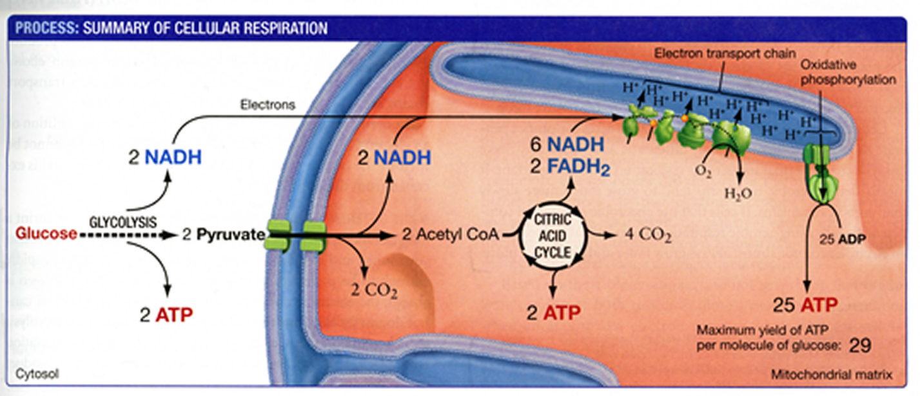(From "Biological Science" by Scott Freeman, Benjamin Cummings, 2011)

The equations and diagram in the Student Handout indicate that cellular respiration generates ~29 molecules of ATP for each glucose molecule; this number is less than previously believed (and often erroneously stated in textbooks). This revised estimate is based on newly discovered complexities and inefficiencies in the function of the electron transport chain and ATP synthase enzyme. The number of ATP molecules produced per molecule of glucose is variable because of variability in the efficiency of the electron transport chain proton pumps and the ATP synthase. These recent findings are interesting as an example of how science progresses by a series of successively more accurate approximations to the truth.

Hydrolysis of creatine phosphate (also called phosphocreatine) can be used to make ATP during muscle contraction (shown on the bottom of page 2 of the Student Handout). During rest (after physical activity or between bouts of intense physical activity), aerobic cellular respiration produces ATP which is used to reverse the reactions shown in the Student Handout and restore the muscle cell’s creatine phosphate supply.

Muscle cells have extreme increases in metabolic demands, with up to 100 fold increases in the rate of hydrolysis of ATP when muscles are active. Therefore, it is not surprising that skeletal muscles contain most of the body’s creatine phosphate (~95% of the total body creatine). Meat and fish provide dietary sources of creatine. Use of oral creatine supplements can lead to increased creatine in skeletal muscles and ~10-15% improvement in performance in brief high-intensity athletic events; use of these supplements can also contribute to improved performance in intermittent high-intensity sports. Use of creatine supplements that do not have contaminants does not appear to result in serious side effects, although weight gain (mainly lean body mass) is common (http://link.springer.com/article/10.2165/00007256-200232140-00003; http://www.jissn.com/content/pdf/1550-2783-4-6.pdf).

Aerobic cellular respiration, anaerobic fermentation, and hydrolysis of creatine phosphate all contribute to ATP production during any physical activity, but the relative contributions vary substantially over time and between different types of physical activity. For brief high-intensity events, the supply of ATP is heavily dependent on the hydrolysis of creatine phosphate and anaerobic fermentation which can supply ATP very rapidly and do not require O₂; when the intensity of muscle activity is very high, the rate of ATP use exceeds the capacity of the circulatory system to supply the muscles with O₂ for selecting contrast anabolic aerobic cellular respiration. However, both the hydrolysis of creatine phosphate and anaerobic fermentation are limited to relatively short time periods, and aerobic cellular respiration is the primary energy source after a minute or two.
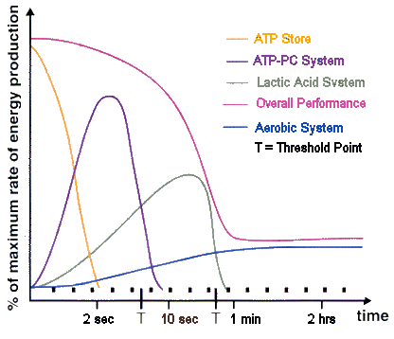
Lactate System = Anaerobic Fermentation
= Aerobic cellular respiration
PC = Phosphocreatine = Creatine phosphate

(http://www.brianmac.co.uk/pictures/physiology/energy.gif)

How Oxygen and Glucose Get to the Muscles
This section provides the opportunity to reinforce the general point that interactions between body systems are important for accomplishing the activities of life. For simplicity and clarity, the Student Handout does not discuss how CO₂ diffuses into the capillaries in muscles and is carried by the blood to the lungs where CO₂ diffuses from the blood into the air in the alveoli. The figure below shows how muscle contraction and relaxation move air into and out of the lungs.
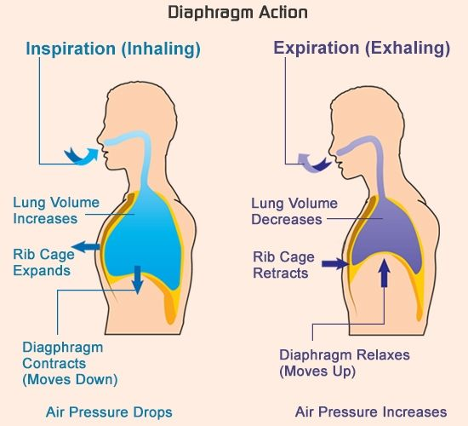
(https://i.pinimg.com/originals/0d/7f/3a/0d7f3ab710f71252b88c0e62f605e246.jpg)

This section and the next illustrate how analysis at different levels – from the molecular to body systems – contributes to our understanding of biological phenomena.

How Regular Aerobic Exercise Can Improve Athletic Performance
Regular aerobic exercise results in changes in the body which are called training effects. For high-intensity physical activity, the supply of O₂ to the muscle is limiting. Thus, improved heart function and increased capillaries in muscles are especially important for delivering more O₂. In addition, regular aerobic exercise results in increased blood volume, stroke volume and maximum breathing capacity. Each of these training effects contributes to increased capacity for aerobic cellular respiration in active muscle cells. Increased capacity for aerobic cellular respiration improves athletic performance, especially in sports that rely primarily on aerobic cellular respiration (e.g. longer running, swimming, or bicycling races).

Questions 11a and 11b guide students in developing the basics of a scientific argument; their answers to 11a provide the claims and their answers to 11b provide the evidence. You may want to have your students use these answers to develop a more complete scientific argument, including a justification of the evidence (http://www.scientificargumentation.com/overview-of-scientific-argumentation.html).

This introductory activity does not discuss glycogen (a polymer of glucose which can provide additional glucose molecules for aerobic cellular respiration and anaerobic fermentation) or fat (which can be broken down to fatty acids and glycerol which muscle cells can use for aerobic cellular respiration). As a result of regular aerobic exercise, muscle cells have more stored glycogen and more of the molecules that facilitate uptake of glucose and fatty acids into cells.
The increased capacity for aerobic cellular respiration reduces the need for anaerobic fermentation; this conserves glycogen stores and prevents the development of acidity, thus delaying fatigue and increasing endurance.

Depletion of the glycogen in skeletal muscles is associated with fatigue. Therefore, for endurance events it is helpful to reduce the rate of utilization of muscle glycogen by consuming food which can supply glucose for muscle cell aerobic cellular respiration. In this connection, you may be interested in the evidence that carbohydrate ingestion before and during endurance events that last longer than an hour can help to prevent fatigue and improve performance (see "Carbohydrate Consumption, Athletic Performance and Health – Using Science Process Skills to Understand the Evidence"; https://serendipstudio.org/exchange/bioactivities/sciproc). In contrast, consumption of fats immediately before or during athletic competitions is not recommended, because long chain fatty acids take too long to digest and medium chain fatty acids cause gastrointestinal distress when consumed in sufficient quantity to provide significant energy.

There are multiple additional effects of training which contribute to both improved athletic performance and health. More information on the effects of training, as well as are more information on the complexities of energy metabolism, is available in "The Surgeon General's Report on Physical Activity and Health" (http://www.cdc.gov/nccdphp/sgr/chap3.htm).

Possible Extension Activity
If your students have questions about other aspects of energy metabolism and athletic activity, you may want to encourage them to investigate these questions and engage in the NGSS-recommended science practices of "asking questions" and "obtaining, evaluating, and communicating information". Possible sources include those already referred to in these Teacher Notes and physiology textbooks. If your students are unfamiliar with how to evaluate the reliability of various sources, this important skill can be introduced with resources available at http://www.library.georgetown.edu/tutorials/research-guides/evaluating-internet-content and http://www.virtualsalt.com/evalu8it.htm.

Related Learning Activities
- "Cellular Respiration and Photosynthesis – Important Concepts, Common Misconceptions, and Learning Activities" (https://serendipstudio.org/exchange/bioactivities/cellrespiration) offers multiple learning activities concerning energy metabolism. For example, "Food, Energy and Body Weight" (https://serendipstudio.org/exchange/bioactivities/foodenergy) discusses the contribution of exercise to weight loss (or prevention of weight gain).
- "Should you drink sports drinks? When? Why?" (https://serendipstudio.org/exchange/bioactivities/sportsdrinks)

Sources of Figures in Student Handout
- Silhouettes of sports figures – modified from https://koohsports.files.wordpress.com/2017/04/33.jpg
- Aerobic Cellular Respiration and Anaerobic Fermentation – modified from https://images.slideplayer.com/32/10058702/slides/slide_14.jpg
- Respiratory and circulatory systems – modified from https://megansbiologyeportfolio.weebly.com/uploads/1/3/8/2/13822667/6761185_orig.jpg and https://cf2.ppt-online.org/files2/slide/4/45jthyOLIGmpqYZiwWelMufTQbaAVz9k1CPcKvoHN/slide-1.jpg
Other figures were prepared by the author.

By Dr. Ingrid Waldron, Department of Biology University of Pennsylvania, 2020. These Teacher Notes and the Student Handout are available at http://serendipstudio.org/exchange/bioactivities/energyathlete.
http://www.nextgenscience.org/sites/default/files/HS%20LS%20topics%20combined%206.13.13.pdf
To draw a line - At the top of the page, find Select line and pick the type of line you want. - Place the line on your drawing: - Line, Elbow Connector, Curved Connector or Arrow: Click to start, then drag across the canvas. - Curve or Polyline: Click to start, then click at each point you want the line to bend. Double-click or complete the shape to finish. - Scribble: Click to start, then drag across the canvas. To draw a shape - At the top of the page, find and click Shape. - Choose the shape you want to use. - Click and drag on the canvas to draw your shape. To insert text - At the top of the page, click Insert. - To place text inside a box or confined area, click Text Box and drag it to where you want it. - Type your text. - You can select, resize and format the word art or text box, or apply styles like bold or italics to the text. When you are done, click Save and Close.
For information about how to make inexpensive whiteboards and use them in your teaching, see "The $2 interactive whiteboard" and "Resources for whiteboarding" in https://fnoschese.wordpress.com/2010/08/06/the-2-interactive-whiteboard/. You can go to Home Depot and ask them to cut a 8' x 4' whiteboard (e.g. EUCATILE Hardboard Thrifty White Tile Board) into six pieces with the dimension 32" x 24". They should have a power saw rig that allows their employees to cut the pieces very easily. They should not charge to cut them and the product cost is reasonable. Some additional tips are: – Coat the white boards with Endust (or similar product) before using. Every once in a while wipe them clean and reapply Endust. – Do not use markers that are old or almost empty. The ink from these are more difficult to erase. – Black markers erase easiest. – Best if boards are erased immediately after use. – Teacher and/or students can take a picture of the information on the whiteboard if they want to save it.
Some organisms use a slightly different type of anaerobic fermentation that produces ethanol; see e.g. our hands-on activity "Alcoholic Fermentation in Yeast" (http://serendipstudio.org/sci_edu/waldron/#fermentation).
"Approximate Yield of ATP from Glucose, Designed by Donald Nicholson" by Brand, 2003, Biochemistry and Molecular Biology Education 31:2-4 (available at http://www.bambed.org).
Anabolic androgen steroids are the most commonly used performance-enhancing drugs. These drugs are often used by bodybuilding young men to increase muscle size and "improve appearance". Anabolic androgen steroids have harmful effects on the circulatory system, mood and behavior (https://www.ncbi.nlm.nih.gov/pmc/articles/PMC4026349/).
There is a relatively limited supply of glycogen in skeletal muscle (enough for less than an hour of moderate intensity activity). A slightly larger amount of energy is available from the fat in muscles. In comparison, there is three times as much glycogen in the liver and roughly 20 times as much fat in adipose tissue. It appears that neither amino acids nor nucleic acids are significant inputs for aerobic cellular respiration in well-nourished individuals.

